Lab 01

Introduction to Circuits & Lab Equipment

Student ID:11428, 11163
Name: Hussain Nasrullah, Arsheel Abbas

Objective
After performing this lab, students should be able to:
    - Identify and use basic electric circuit components.
    - Identify and work with lab equipment.
    - Build and test simple circuits

Understanding Electric Circuit
Logic Circuits are basically electric circuits which implement certain logical function. Before we dive into building logics, it is important to understand basics of electric circuit. An electric circuit usually consists of three main parts i.e., a source of energy, electronic components and conductors. A source of energy pushes the charged particles (i.e., electrons) from one terminal to other, we call that pushing force as Electromotive Force (emf) or Voltage Source. It will usually be supplied by battery or a power supply in our circuits. Electronic components include variety of devices like resistors, capacitors, switches, LEDs (Light Emitting Diodes), transistors, integrated circuits etc. Conductors are wires which connect one component with another as per specific type of diagram called Schematic diagram (See Figure 1). Figure 1a shows an electric circuit and Figure 1b shows the schematic representation of it.

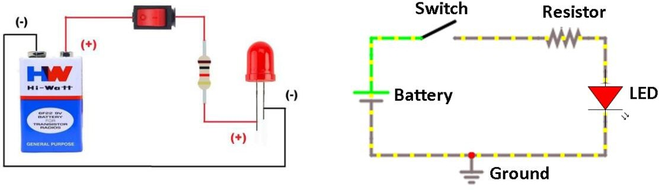
(a)
(b)
Figure 1: (a) Picture of an electric circuit (b) Schematic diagram of an electric circuit

For an electric circuit to work the charged particles must flow in a closed loop. When loop is complete, charges move from one terminal of the battery to the other terminal. This movement of charges is called electric current. Conventionally, the direction of electric current is considered from positive terminal of battery to negative terminal as shown in Figure 2.


When switch is in OFF condition it is called open switch (Figure 1b) and when it is in on condition it is called Closed Switch (Figure 2)

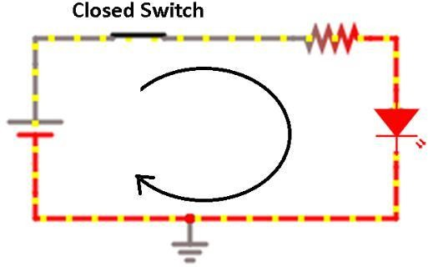
Figure 2


Voltage is measured between two points in a circuit. Typically, one point is specified as reference of measurements called ground (See Figure 1b for ground symbol). Thus, voltage at any point is specified with respect to ground.

Task a)

For the circuit in Figure 3, following the direction of current, determine the state of LED (ON/OFF) when switches A and B are toggled in the sequence provided in Table 1.
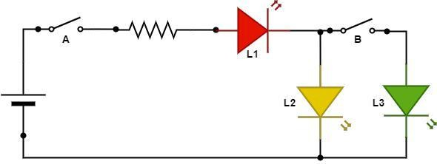
Figure 3: Circuit schematic
Table 1-Toggling sequence of switches A and B

A | B | L1 | L2 | L3
Open | Open | OFF | OFF | OFF
Open | Close | OFF | OFF | OFF
Close | Open | ON | ON | OFF
Close | Close | ON | ON | ON

Slide switch button
A switch is a device used for making and breaking electrical connection. Figure 4 shows commonly used Sliding Switch.
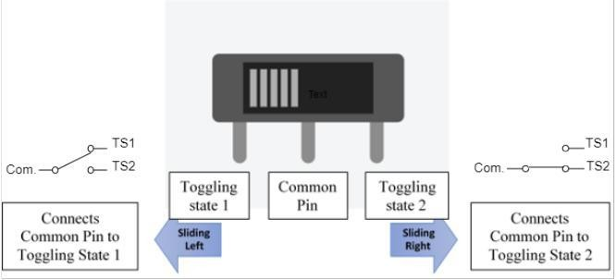
Figure 4: Sliding switch

This switch has a common pin and the other two pins are toggling in nature. You can connect the circuitry with one of the toggling pins and leave the other pin unconnected as shown in Figure 4. The center pin is the common pin whereas the extreme pins are the toggling state 1 and toggling state 2.

Light Emitting Diode (LED)
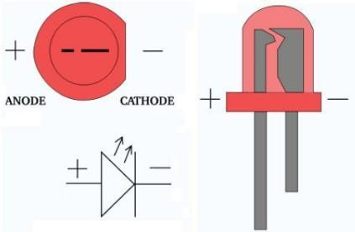
An LED (Light Emitting Diode) is a two terminal electronic component that lights up when current flows through it. LEDs are available in many colors including much of the visible spectrum as well as infrared. LED is polar device which means for LED to turn on current must enter into anode (the longer lead, see Figure 5) not the other way around.

Figure 5: LED internal diagram

Building Electrical Circuits on Bread Board

Lab Equipment and Components

Power Supply
As discussed in section a. Power supplies are used to provide electric energy to a circuit. A DC (Direct Current) power supply pushes electric current in one direction hence the name. The direction of current supplied is from positive (i.e., red) to negative (i.e., black). DC Power supply maintains constant voltage between two terminals (i.e., red and black). The value of voltage is selected by rotary knob as shown in Figure 6. Watch this quick Power Supply Tutorial on how to use DC power supply (used in our lab).
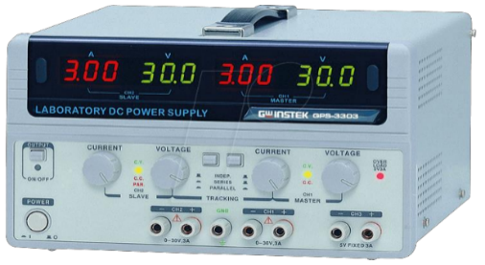
Figure 6: Power Supply used in DLD lab

Breadboard
A breadboard is a rectangular plastic board with a bunch of tiny holes in it as shown in Figure 7. It is one of the most fundamental pieces of equipment when learning to build circuits and is used to make temporary circuits (i.e., prototypes). Notice in Figure 7 that rows are marked with alphabet letters and numbers represents columns.
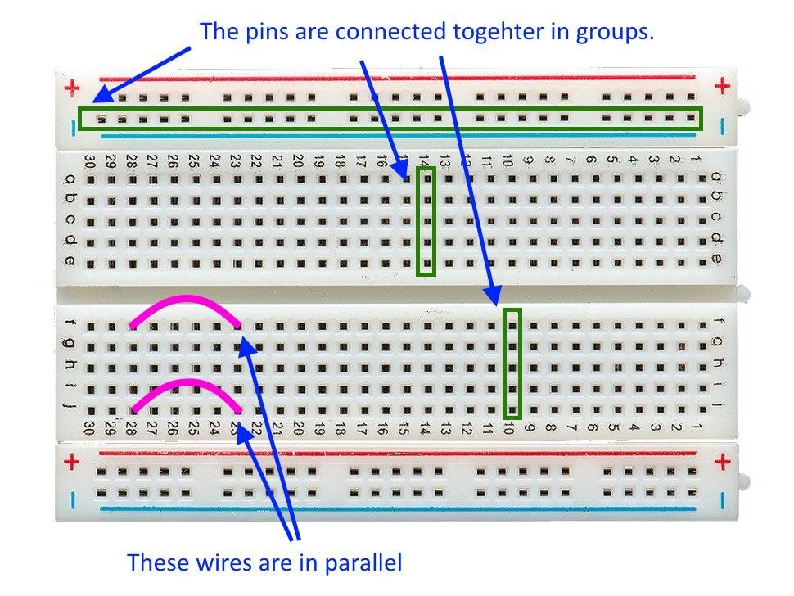 | 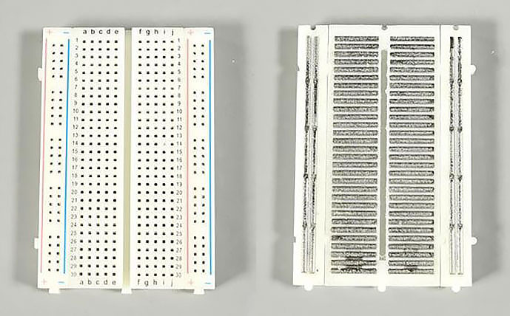
Figure 7: Breadboard connections | Figure 8: Internal connections of breadboard
- The extreme large green rectangle consists of five set of holes all connected to each other (see Figure 11). As indicated this point is used for supplying the negative terminal of the battery (i.e.,, black) to the circuit. On top of it, there lies a similar set of holes connected to each other but not connect to holes in green rectangle. That is used for providing the positive terminal of battery (5V in our case) to the circuit.
- Inside these power and ground lines, we make our desired circuitry using the electronic components. The abcde holes are all connected vertically and likewise, fghij. This is also indicated by the two small green rectangles in Figure 7.
- The ICs are placed in between the ‘e’ and ‘f’ holes i.e., the gap line between the holes. For connecting the hole in parallel we use jumper wires as shown 28j hole is being connected to 23j and likewise 28f is connected to 23f. This schematic makes both wires in parallel combination. Watch this Breadboard Tutorial to learn more about the breadboard.
Task b)
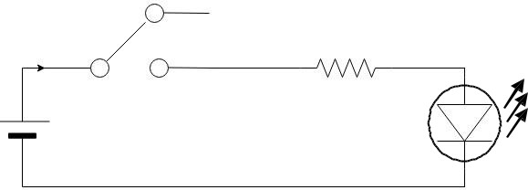
In this section, we will build a simple circuit using bread board, some discrete components and basic lab equipment
1kΩ
5V

Figure 9: Schematic

- Components required
  - Breadboard
  - Power Supply
  - Slide switch
  - Resistor
  - LED

- Procedure and observations
- Make sure the breadboard is well placed on your workstation. (Remember neatness is one of the keys that helps you to troubleshoot your circuits, and gain marks in your rubric table).
- Placing Component on breadboard:
First place your slider switch on breadboards and connect it to the positive end of the power supply.


For connecting sliding switch, connect common pin to the circuit and one toggling pin to the power source. You can leave the second toggling pin unconnected for now, its usage will be discussed in forthcoming labs.

- Now place the LED on the breadboard. Be careful while connecting the positive and the negative terminals of the breadboard to the circuit, now connect one end of the resistor to the switch and its other end to LED.

- Make sure that all your circuit components are properly connected to each other. You may need to use wires, cutter or strippers for making connections. Refer to Figure 9 for correct component placement.

- Adjust your power supply to 5 V and connect your circuit to power supply using the probes.

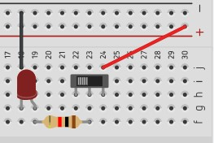
Figure 10: Reference Circuit

- Fill the following Table 2 based on your observations.

Table 2: Data table
SW 1 | LED(D1)
Open | OFF
Closed | ON

Task c)

Introduction to Switches and Logic
- Build the provided schematic as shown in Figure 8 on breadboard; consider switches SW1 and SW2 as slide switches.

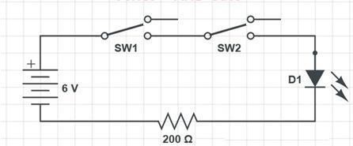
Figure 11: Schematic

- Toggle switch SW1 and SW2 one by one and note down your observations for LED in Table 3.
Table 3: Data Table

SW1 | SW2 | LED (D1)
Open | Open | OFF
Open | Closed | OFF
Closed | Open | OFF
Closed | Closed | ON

Can you think of a logic function which this circuit represents? AND

- Now think of developing OR logic, using two slide switches and LED. Test your proposed design and verify it on the breadboard. Fill your observation in Table 4 and provide circuit design in the space below:

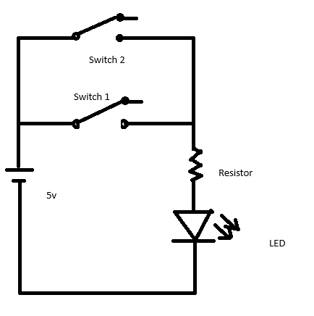
Table 4: Data table
SW1 | SW2 | LED (D1)
Open | Open | OFF
Open | Closed | ON
Closed | Open | ON
Closed | Closed | ON

Task d) Using DIP Switches

- Dual inline Package (DIP) switch is special type of switch which consists of many single contact switches and its shape is similar to an IC that fits in middle two lines of breadboard.
- In this exercise you need to display the last digit of your student ID number using a LED combination with the help of 4-bit switches. As an example, let’s say your ID is 2216, so for its last digit ‘6’ your 4-bit binary code to be displayed on LED is 0110. Refer to Figure 12.
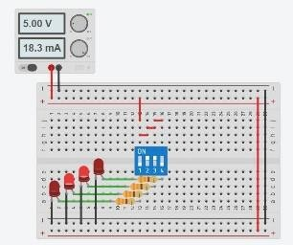
Figure 12: Example of display

- Provide the circuit diagram in the space below:
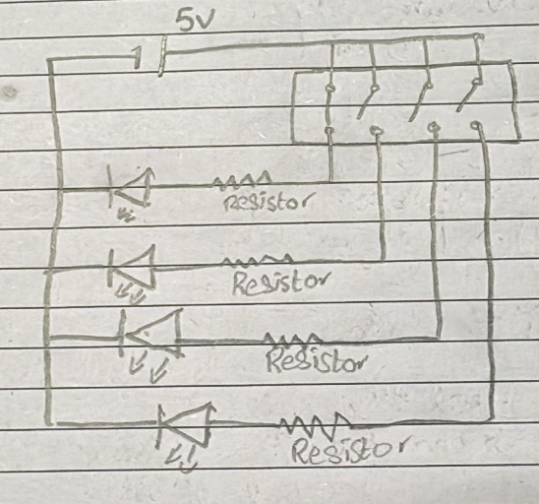

- Highlight some differences between Sliding Switch and DIP switch.

Sliding switch contains three legs for a switch allowing to make two connections of difference sources in two different toggle states whereas DIP only contains one source connection with two legs per switch, other state just opens the circuit.
DIP contains multiple independent switches in a single IC with compact design. Sliding switch is just one switch.

Measure current flowing through the branch(es)
Task e)
Analyze the circuit given in Figure 9. Comment on, what will happen when we decrease and increase the resistance values in this circuit.
As resistor is connected in series, when resistance is increased it will consume more power and LED will have less power hence lower brightness. On less resistance, LED will have more power hence more brightness.

Record the current flowing in the circuit or the resistance values mentioned in Table 5. Change the value of resistor one by one and fill the Table below. Watch this Tutorial for Multimeter Tutorial for Multimeter for details of its operation and working.
Table 5: Data table

Resistance (Ω) | Current (A)
330 | 0.16 A
1K | 0.571 A
10K | 0.0564 A

Assessment Rubric Lab 01
Introduction to Circuits & Lab Equipment

Student ID: 11428, 11163
Name: Hussain Nasrullah, Arsheel Abbas

Marks Distribution:

 | Task No. | LR1  Circuit Layout | LR5  Results | LR10  Analysis | LR11  Design
In - Lab | Task a | - | /05 | - | -
 | Task b | /05 | /05 | - | -
 | Task c(i) | /05 | /05 | - | /05
 | Task c(ii) | /05 | /05 | - | /05
 | Task d | /10 | /05 | - | /10
 | Task e |  | /05 | /10 | /05
Post - Lab
Total = /100 |  | /25 | /30 | /10 | 25
CLO Mapping |  | CLO 1 | CLO 1 | CLO 1 | CLO 1

Affective Domain Rubric |  | Points | CLO Mapped
AR 7 | Report Submission, Performance and Viva | /10 | CLO 4

CLO | Total Points | Points Obtained
1 | 90
4 | 10
Total | 100

For description of different levels of the mapped rubrics, please refer to the provided Lab Evaluation Assessment Rubrics and Affective Domain Assessment Rubrics.

Lab Evaluation Assessment Rubrics

# | Assessment Elements | Level 1: Unsatisfactory Points 0-1 | Level 2: Developing  Points 2 | Level 3: Good  Points 3 | Level 4: Exemplary  Points 4
LR1 | Circuit Layout | Connections between circuit components are mostly wrong. Circuit layout is cluttered.  Needs guidance to make correct equipment/ component connections. | Few of the connections made between circuit components are wrong. Circuit layout is not neat and clean as per standards. | Circuit layout and connections are correct but not all connections are neat and clean as per standards. | Neat, clean and correct connections of all the circuit components/ equipment are made as per standard circuit diagram.
LR3 | Troubleshooting | Unable to identify the fault/minimal effort shown in troubleshooting. | Able to identify the fault but unable to remove it. | Able to identify the fault but partially removes it. | Able to identify the fault and takes necessary steps and actions to correct it.
LR5 | Results & Plots | Figures/ graphs / tables are not developed or are poorly constructed with erroneous results. Titles, captions, units are not mentioned.  Data is presented in an obscure manner. | Figures, graphs and tables are drawn but contain errors. Titles, captions, units are not accurate. Data presentation is not too clear. | All figures, graphs, tables are correctly drawn but contain minor errors or some of the details are missing. | Figures / graphs / tables are correctly drawn and appropriate titles/captions and proper units are mentioned. Data presentation is systematic.
LR7 | Viva | Response shows a complete lack of understanding of the assigned / completed task | Response shows shallow understanding of the assigned task | Response shows substantial understanding of the assigned task | Response shows complete understanding of the completed task. The student is able to explain all the related concepts.
LR10 | Analysis | Results are not interpreted or are analyzed incorrectly. | Analysis of the obtained results is incomplete.  Conclusions are not drawn. | Results are analyzed and concluded but are not well explained and justification is not provided with the help of reasoning. | Results are well analyzed supported with reasons. Good comparison is made between the theoretical and experimental results with correct and useful conclusion.
LR11 | Design | Proposed design is unsubstantiated or does not satisfy most of given constraints. The breakdown of system into features is incomplete and still at lower resolution. | Justification for proposed design is weak, and it only satisfies some constraints. The breakdown of system is missing some features and resolution is not appropriate at some places. | Proposed design is substantiated, preferably through proper analysis, and satisfies most given constraints. The breakdown of system into features seems complete, but resolution is not appropriate at some places. | Proposed design is substantiated, preferably through proper analysis, and satisfies all given constraints. The breakdown of system into features seems complete and at appropriate resolution, given students' level.

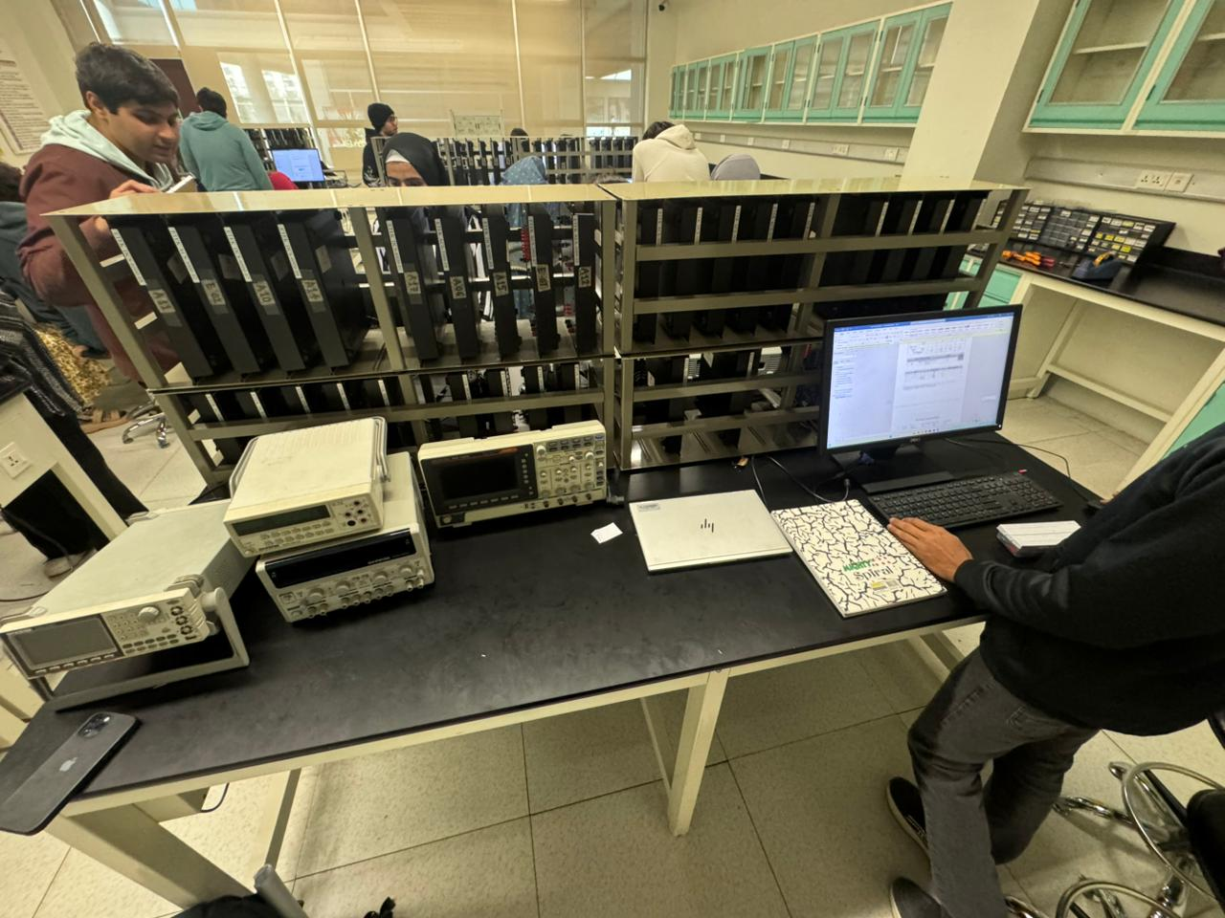

Strictly it does not supply force rather provides difference in potential energy. And charge carriers move from one potential to other.

